Exercise 6
- Order all employees on the basis of the salary they draw.
Answer: SELECT *
FROM employee_data
ORDER BY salary;
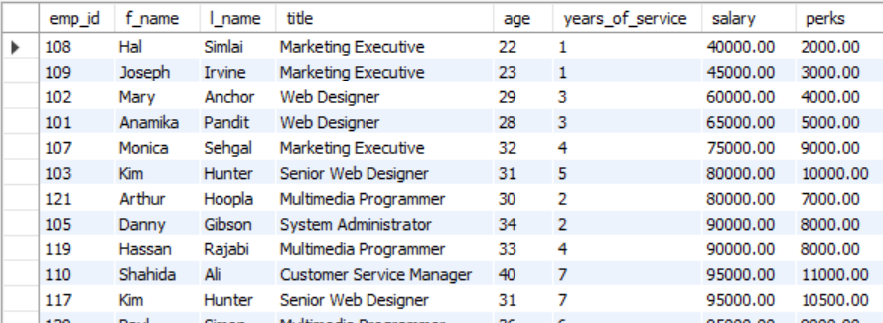

- List all employees in descending order of their years of service.
Answer: SELECT *
FROM employee_data
ORDER BY years_of_service DESC;
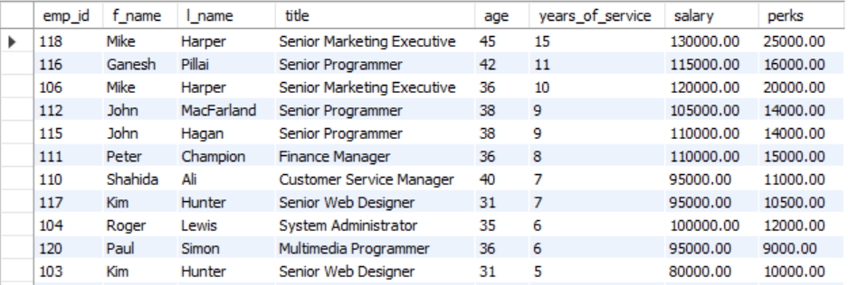

- What does the following statement display?
Answer:
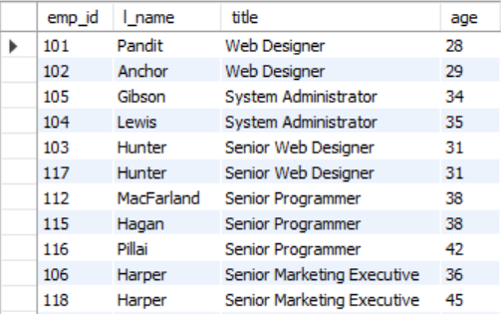

- Display employees (last names followed by first names) who hold the title of either “Programmer” or “Web Designer” and sort their last names alphabetically.
Answer:


